WordPress Installation Manual

9346B

Group 4

Andrada, Jason

Guiab, John Carlo

Patricio, Jan Ronald

Pis-o, Henrod

Viloria,Brendon Bruce

De Vera, Melody Riza

Lonogan, MehanieJiral

Rocafort, Jam Spica

Willy, Kim

Table of Contents

PREREQUISITES 1

**LAMP (Linux, Apache, MySQL and PHP):** 1

WordPress needed LAMP in order to function correctly, it will use the web server, a database and php. 1

To install LAMP server while setting up the Ubuntu server, mark the LAMP server as one of the needed software. See image below: 1

Then after that set a password for MySQL administrative “root user”. 1

**Enable .htaccess Overrides** 3

**Enable mod_rewrite** 3

Download WordPress 3

**Change premissions** 3

**Configure WordPress config file** 4

Install WordPress on your Website Using a Web Browser 5

# PREREQUISITES

## 

## **LAMP (Linux, Apache, MySQL and PHP):**

## WordPress needed LAMP in order to function correctly, it will use the web server, adatabase and php.

## To install LAMP server while setting up the Ubuntu server, mark the LAMP server as one of the needed software. See image below:

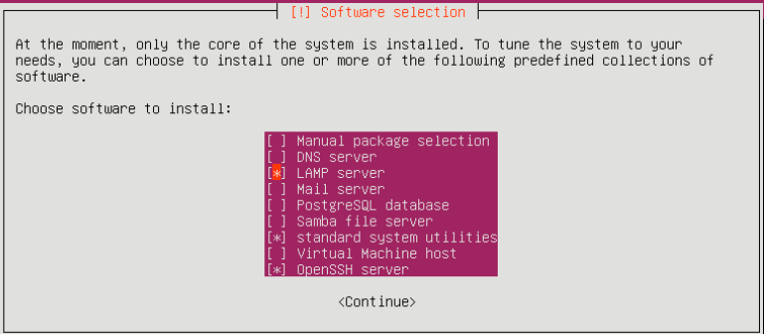

## Then after that set a password for MySQL administrative “root user”.

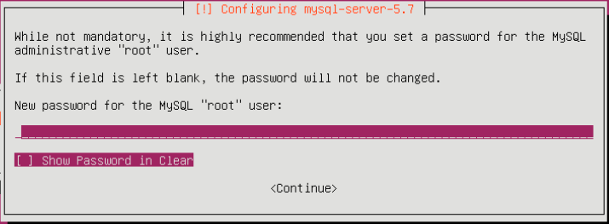

Create a MySQL Database and User for WordPress

First step is use MySQL to store site and user information. Then we need to create a database for WordPress.

To get started issue the command below:



Now it is in MySQL command then create a database for the WordPress by typing the command below:



Then after creating a database for the WordPress create a user for the database that will manage the site and then grant access to the database that we created. By issuing the command below:



Then the recent changes that we’ve made must be saved by typing the command below:



Now that the database is done. We can now exit out MySQL by typing the command below:



**Install Additional PHP Extensions**

Download and Install PHP extensions for the WordPress by issuing the command below:



Then after that restart the apache by issuing the command below:



Configure Apache .htaccess Overrides and Rewrites

## **Enable .htaccess Overrides**

Then to enable .htaccess, Open the Configuration file of the primary Apache:



Then add this few lines to the primary apache configuration:



## 

## **Enable mod_rewrite**

So that we can initialize the WordPress permalink feature type the command below:



Then to implement the changes that we’ve made restart apache:

# 